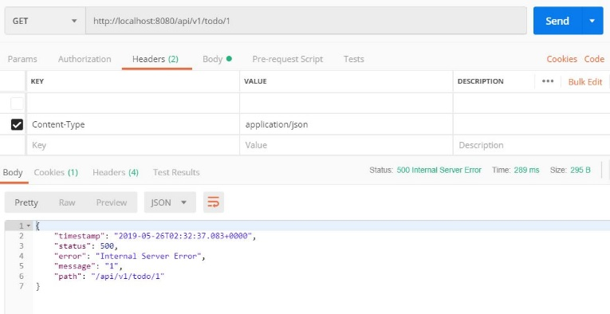

*Không Handle Exception*

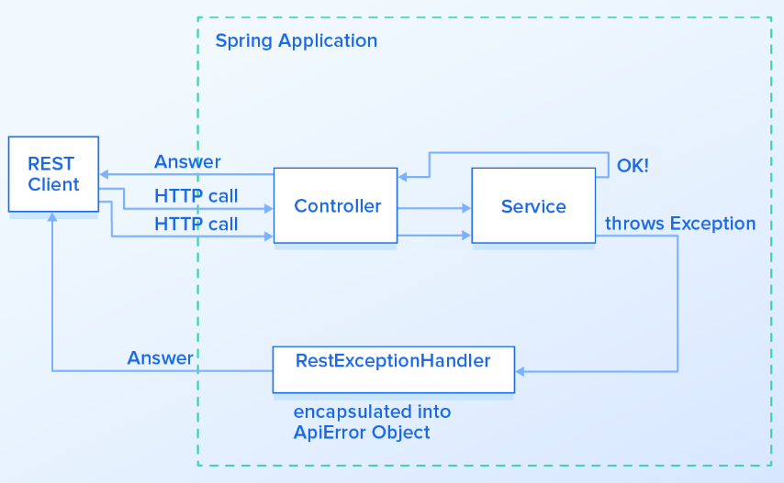

*Handling Exception Flow*

* VD1: twitter

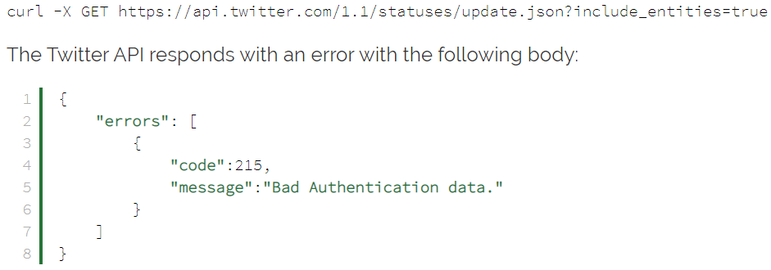

VD2: facebook

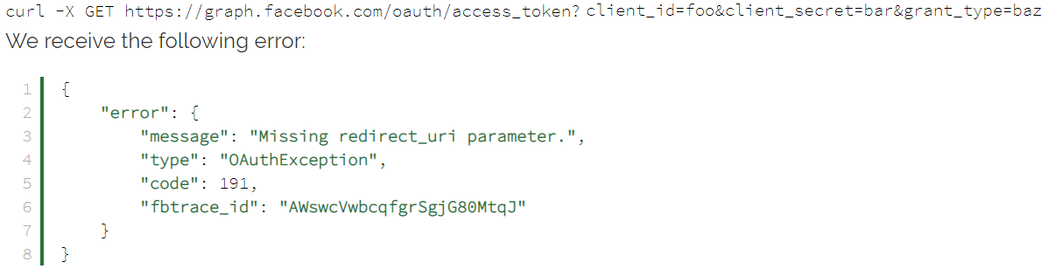

* **Các loại**
  + Trước spring 3.2 thì có 2 cách tiếp cận
    - **Controller level** (local exception)

@ExceptionHandler

* + - **Application level** (global exception)

HandlerExceptionResolver

* + Từ spring 3.2

Có thêm **@ControllerAdvice** để handling exception cho global exception

* + Từ Spring 5

Có thêm **ResponseStatusException class** để handling exception cho local exception

* **Cách xử lý**
  + **@ControllerAdvice** cho **global exception**
  + **ResponseStatusException** cho **local exception**
* **Design**

<https://www.baeldung.com/rest-api-error-handling-best-practices>

* **Hateoas links**

<https://www.baeldung.com/spring-hateoas-tutorial>

<https://spring.io/guides/gs/rest-hateoas/>

<https://dzone.com/articles/applying-hateoas-to-a-rest-api-with-spring-boot>

* **Reference**

<https://www.baeldung.com/exception-handling-for-rest-with-spring>

<https://www.toptal.com/java/spring-boot-rest-api-error-handling>